Intellectual Need Task for Limit Definition of Derivative

Vicki took 400 mg of Ibuprofen to relieve knee pain. The amount (mg) as a function of elapsed time (hours) is f(t)=400(0.71)t.
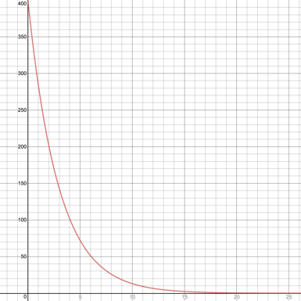

Approximate the rate of change of the amount of Ibuprofen in Vicki’s body with respect to the number of hours elapsed when t=4:
    - -35 mg/hour
    - -35 mg
    - 100 mg/hour
    - 100 mg
    - 25 mg/hour
    - 25 mg

