Intellectual Need Task for Implicit Differentiation

Below is a graph of (x²+y²+1.2x)²=1.2(x²+y²)

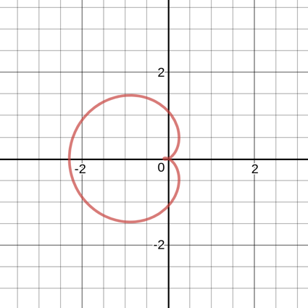
What is the slope of the tangent line to the curve at the point (0,1.2)?
- -5/6
- 0
- -6/7
- -1
- -7/8

