Instructions for Downloading a Ximera Certificate

- After you have completed a Ximera assignment, you will see a “Complete” page with a link to view your certificate, as shown below. Click on the link.
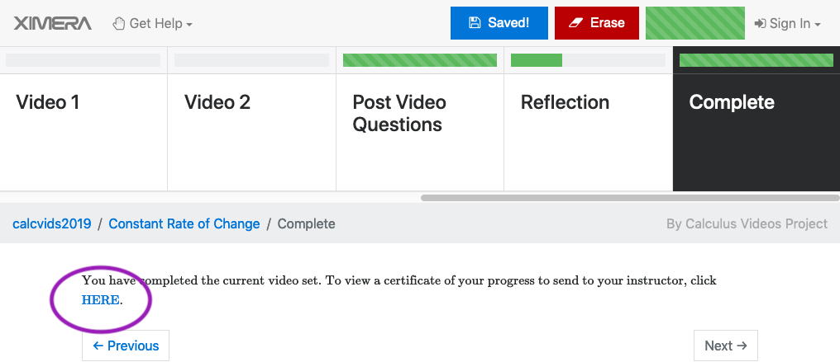
- You’ll see your certificate displayed in your web browser; it will look something like this:
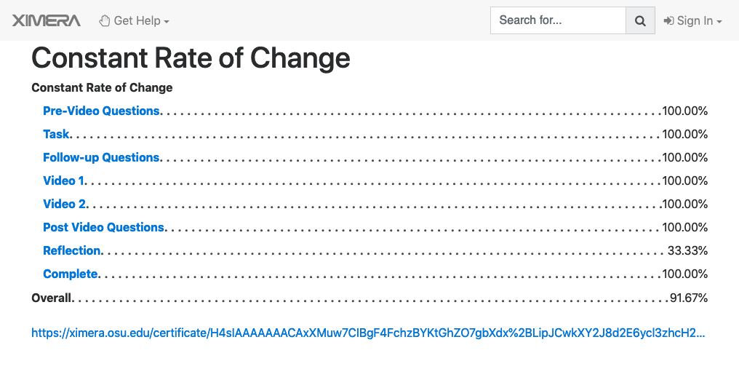

- To download this certificate as a PDF file:
  - Instructions for Google Chrome
    - On Windows, hold the “Control” key and press “P”.
    - On a Mac, either hold the “Command” key and press “P” or click on the “File” menu and select “Print”
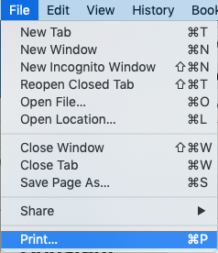
    - In the window that appears, next to Destination select “Save as PDF”
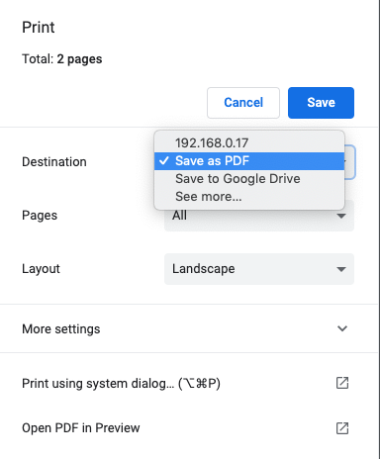
    - Click “Save”

  - Instructions for other browsers on a Macintosh computer:
    - Click on the “File” menu and select “Print.” Alternatively you can hold down the command key and press “P”
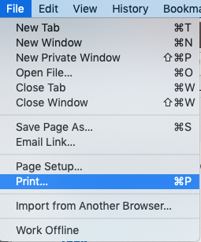
    - Click on “PDF” and then “Save as PDF” as shown below
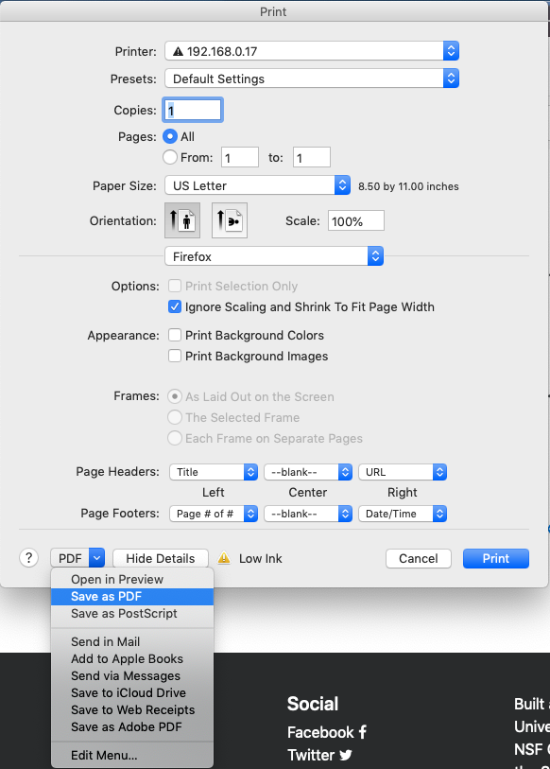

  - Instructions for other browsers on Windows computers:
    - Hold down the control key and press “P”
    - In the dialog box that appears, select “Microsoft Print to PDF” and then click “Print”
