Intellectual Need Tasks

- Constant Rate of Change
  - Context: [Students are shown an animation of water being poured from a pitcher into a cylindrical cup (at a varying rate with respect to time); the cup starts with some water already in it.]
  - Task: You’ll see a pitcher pouring water into a cylinder and answer the question: What is the rate of change of height with respect to volume?
    - Constant
    - Increasing
    - Decreasing
    - Both Increasing and Decreasing
    - Other
- Graphing Constant Rate of Change
  - Context: [Students are shown an animation of a cow being shot directly upward from a cannon; halfway through its descent, a parachute opens, slowing its rate (with respect to time) of descent.]
  - Task: Graph the cow’s height off the ground as a function of total distance traveled.
    - 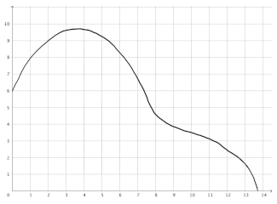
    - 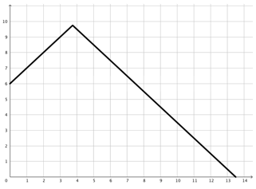
    - 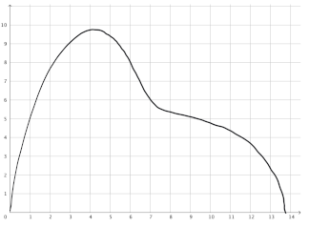
    - 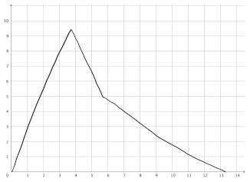
    - 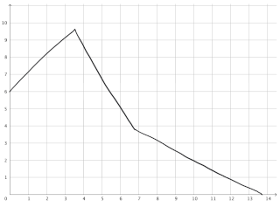
- Increasing Rate of Change
  - Context: [Students are shown an animation of water being poured from a pitcher into an Erlenmeyer flask (the height of the water in the flask rises at a constant rate with respect to time); the flask starts with some water already in it.]
  - Task: You’ll see a pitcher pouring water into a cylinder and answer the question: What is the rate of change of height with respect to volume?
    - Constant
    - Increasing
    - Decreasing
    - Both Increasing and Decreasing
    - Other
- Graphing Increasing Rate of Change
  - Context: You are pouring soda into a bottle. Below is a graph of the height of the soda in the bottle as a function of the volume of soda you have poured:
  - Task: Which of the following bottles best matches this graph?
- Average Rate of Change
  - Context: [Students are shown an animation of two toy cars racing: they start at the same position and move from left to right.]
    - The blue toy car is spring-loaded. The distance d (in inches) of the car from its starting position t seconds since the car started moving is d = 2.8t².
    - The red toy car is battery powered and travels at a constant velocity.
    - The blue car passed the red car 5 seconds after they started.
  - Task: What was the average speed of the blue car over the first 5 seconds?
- Approximating Instantaneous Rates of Change
  - Context: [Students are shown a pitcher of a batter swinging at a baseball as it passes over home plate.] Below is a picture of a baseball player trying to hit a baseball. A typical pitch travels from the pitcher’s mound to home plate in 0.4 seconds. In a standard baseball field, the distance from the pitcher’s mound to home plate is 60 feet, 6 inches.
  - Task: At the moment the photo was taken, how fast was the baseball traveling?
    - 60.5 feet divided by 0.4 seconds (151.25 feet per second)
    - Less than 151.25 feet per second, because the ball was slowing down
    - Greater than 151.25 feet per second
    - You can’t tell without more information
    - The ball isn’t moving in the photo, so it technically has no speed
- L’Hopital’s Rule
  - Context: [Math]
  - Task: Evaluate $\lim_{x→0^{+}}{x\ln{x}}$
- Continuity
  - Context: [Math]
  - Task: For each of the functions below, at which points (if any) is the function not continuous?
    - $f\left(x\right)= \left\{\begin{matrix}2x^{3}+1 & x≥0 \\ -3x+1 & x<0\end{matrix}\right.$
    - $g\left(x\right)=\frac{x^{2}-4}{x-2}$
    - $h\left(x\right)= \sin\left(\frac{1}{x}\right)$
    - $j\left(x\right)=x\sin\left(\frac{1}{x}\right)$
    - $k\left(x\right)=\left|\frac{1}{x}\right|$
- Differentiability
  - Context:: A rabbit breeder currently has 10 female rabbits. She controls their breeding so that they all mate with males at the same time, have a litter approximately 1 month later, and then wait an additional 2 months before mating again.
    - P(t) is number of rabbits at time t in months
    - The size of the population P(t) can be modeled by the formula $R\left(t\right)=10×2^{t}$, where t is measured in months.
  - Task: How quickly is the rabbit population growing at t=1 and at t=2?
- Limit Definition of Derivative
  - Context: Vicki took 400 mg of Ibuprofen to relieve knee pain. The amount (mg) as a function of elapsed time (hours) is f(t)=400(0.71)t.
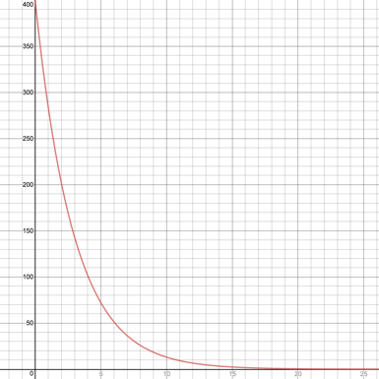
  - Task: Approximate the rate of change of the amount of Ibuprofen in Vicki’s body with respect to the number of hours elapsed when t=4:
    - -35 mg/hour
    - -35 mg
    - 100 mg/hour
    - 100 mg
    - 25 mg/hour
    - 25 mg
- Using the Limit Definition of Derivative
  - Context: Let x represent the area of a square with increasing side lengths.
  - Task: What is the rate of change of the side length of the square with respect to the square’s area when the area is 5 square units?
- Interpreting Derivatives
  - Context: Courtney is going on a road trip. The function f(t) measures the amount of fuel Courtney’s car has consumed (in gallons) where t is measured in hours since Courtney left her hometown.
  - Task: Explain what f’(5)=2.5 means.
    - Courtney’s car had 2.5 gallons of fuel in its tank 5 hours after leaving her hometown.
    - The instantaneous rate of change at 5 hours is 2.5 gallons per hour
    - Courtney’s car consumed 2.5 gallons of fuel during the first 5 hours of her drive from her hometown.
    - The amount of fuel Courtney’s car consumed increased by 2.5 gallons each hour over the first 5 hours since leaving her hometown.
    - Starting at 5 hours, during the next hour, Courtney’s car will consume another 2.5 gallons of gas.
    - Something else
- Slopes of Secants and Tangents
  - Context: Below is a graph of a function
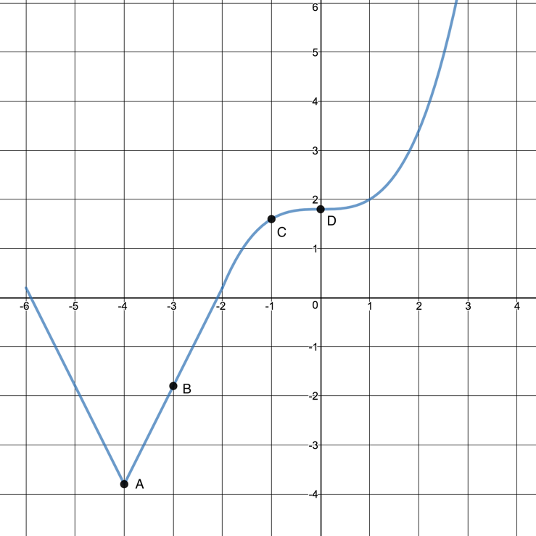
  - Task: Which of the following shows the tangent line to the graph at point B?
    - 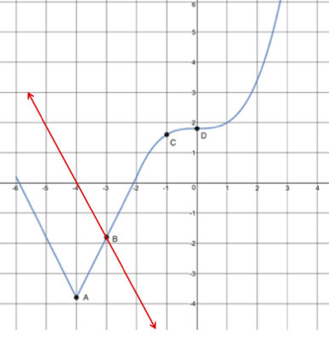
    - 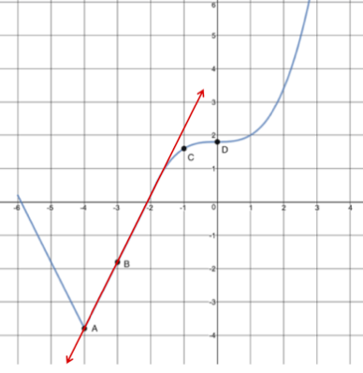
    - The tangent line exists, but isn’t either of the previous options
    - There is no tangent line to the graph at point B
  - Task: Which of the following shows the tangent line to the graph at point A?
    - [Options haven’t yet been created]
  - Task: Which of the following shows the tangent line to the graph at point C?
    - [Options haven’t yet been created]
  - Task: Which of the following shows the tangent line to the graph at point D?
    - [Options haven’t yet been created]
- Graphing Derivatives
  - Context: [Students are shown a video of a person throwing a football (from the side); the thrower’s arm briefly pauses while the football is up behind his head.]
  - Task: Which of the following graphs shows the speed of the football?
- Basic Derivative Rules
  - Context: [math]
  - Task: Find derivative functions for
    - f(x)=4
    - g(x)=2x³-3x+π
    - h(x)=sin(x)+ln(x)
- Product Rule
  - Context: [math]
  - Task: Find the derivative of $f\left(x\right)=(3x-2)(2x+1)$
- Quotient Rule
  - Context: [math]
  - Task: If $f\left(x\right)=\frac{e^{x}}{x^{2}+1}$ determine $f'\left(x\right)$
- Chain Rule
  - Context: A rock is thrown into a pond, creating a circular ripple that travels outward. As the ripple travels, it displaces sediment on the bottom of the lake.
    - R(t) is the radius of the ripple t seconds after the rock hits the surface of the pond.
    - V(r) is the volume of displaced sediment from a ripple that has radius r.
    - The total displacement is given by D(t) = V(R(t)).
Tables:
t R(t)  1 2  2 4  3 6  4 8  5 10  6 12  7 14  8 16  9 18  10 20 | r V(r)  1 5  2 10  3 15  4 20  5 25  6 30  7 35  8 40  9 45  10 50
  - Task: Determine the average rate of change of D(t) with respect to t between t=1 and t=3. What about between t=1 and t=4?
- The Mean Value Theorem
  - Context: [Math]
  - Task: For each of the following functions, locate a value for $c$ in the interval $\left(-2,7\right)$ where $f^{'}\left(c\right)={\frac{f\left(-2\right)-f(7)}{9}}$
    - 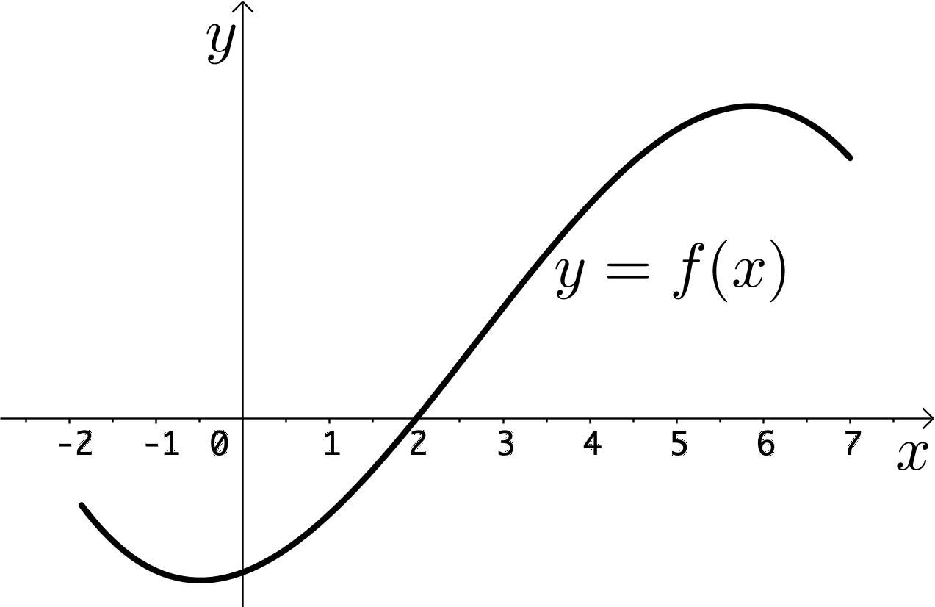
    - 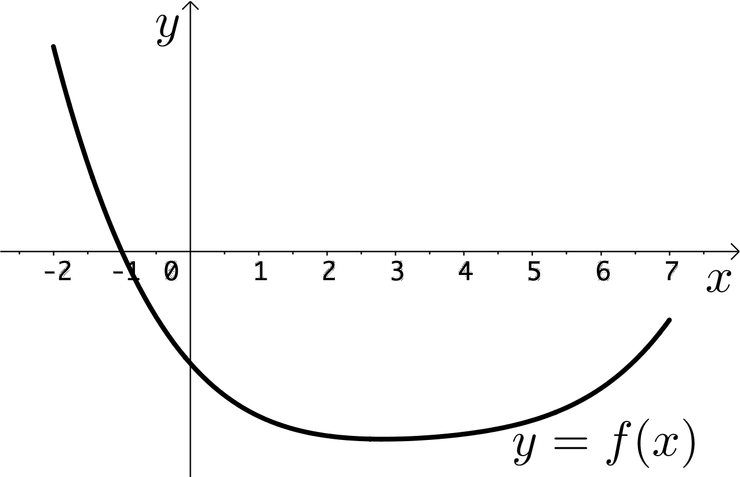
    - 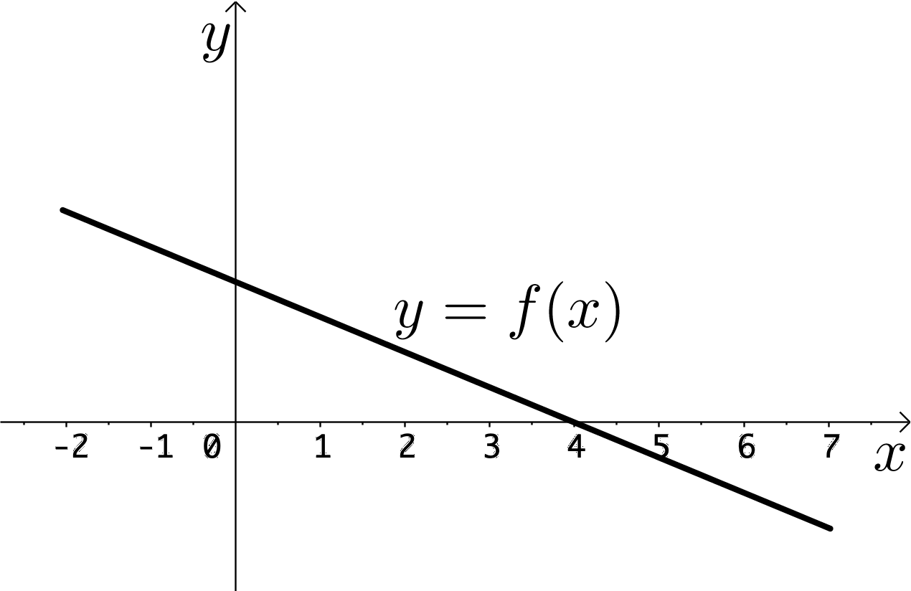
    - 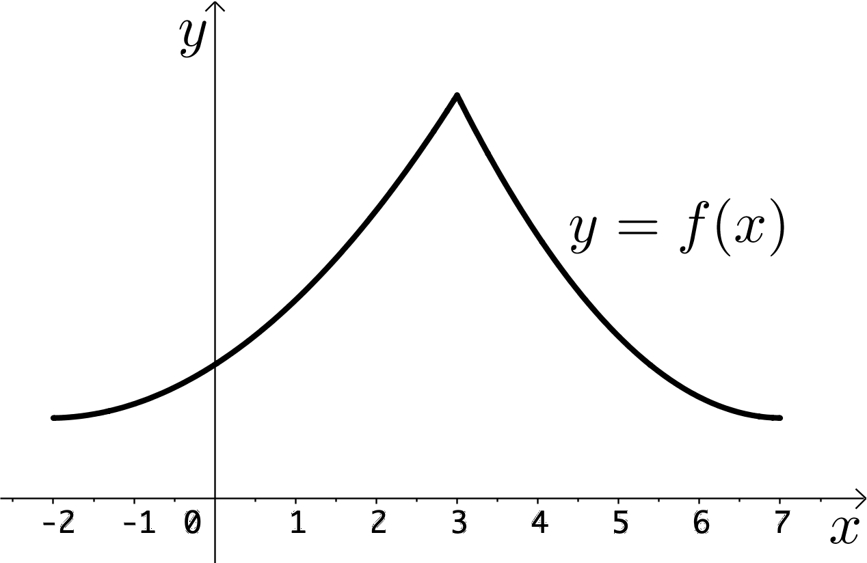
- The Extreme Value Theorem
  - Context: [Math]
  - Task: For each interval below, does the function (graphed below) attain a maximum and minimum value?
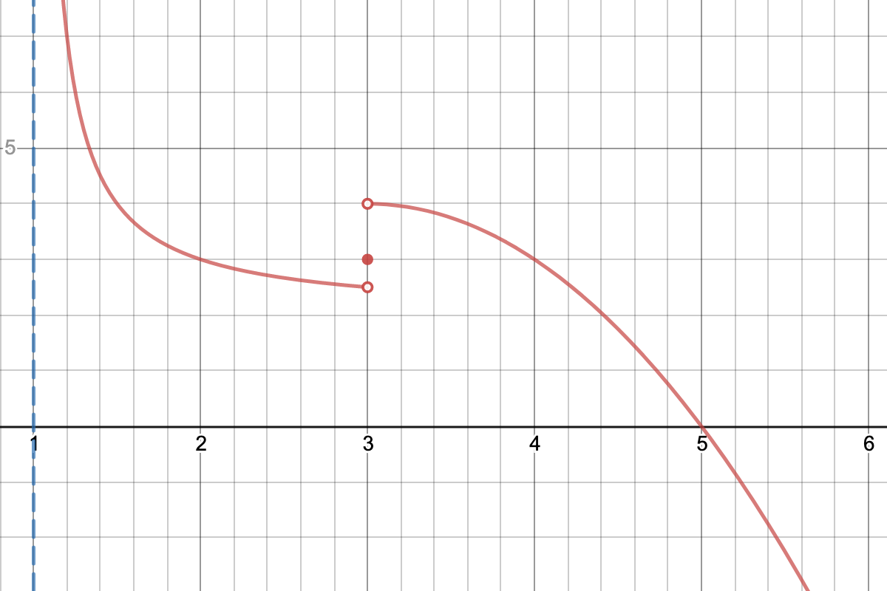
    - (1, 2.5)
    - [1.25, 2]
    - [1.25, 2)
    - [1.5, 3]
    - [2, 3.5]
- Implicit Differentiation
  - Context: [Math]
  - Task: Below is a graph of (x²+y²+1.2x)²=1.2(x²+y²)
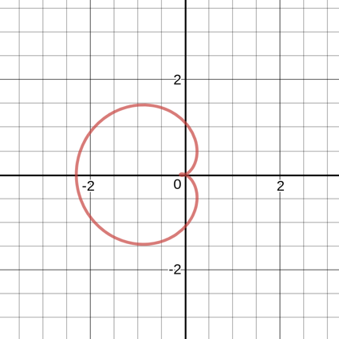
What is the slope of the tangent line to the curve at the point (0,1.2)?
    - -5/6
    - 0
    - -6/7
    - -1
    - -7/8
- Related Rates
  - Context: A spherical balloon is being filled with helium at a constant rate of 90 cubic inches per second.
  - Task: How fast is the radius of the balloon changing when its volume is 246 cubic inches?
- Optimization (Introduction)
  - Context: Below is a table that shows the fuel economy of a car driving at different speeds.
Speed (miles per hour) | Fuel economy (miles per gallon)
45 | 43
50 | 44
55 | 45
60 | 41.5
65 | 38
70 | 35
75 | 32

  - Task: How fast should you drive a car to use fuel as efficiently as possible?
    - 45 miles per hour
    - 50 miles per hour
    - 55 miles per hour
    - 60 miles per hour
    - 65 miles per hour
    - 70 miles per hour
    - 75 miles per hour
    - None of the above
    - You can’t tell without more information
- Optimization (Modeling)
  - Context: A farmer wants to start raising goats. She has 300 ft of fence. She decides to build a rectangular lot (small pen) next to the barn where she keeps feed.
  - Task: What is the largest area lot that she can build?
    - 150 ft
    - 75 ft
    - 100 ft
    - 90000 ft^2
    - 11250 ft^2
    - 5625 ft^2
    - Other
- Riemann Sums (Introduction)
  - Context: The Opportunity rover landed on Mars in 2004 and has been actively exploring the planet ever since. It is powered by solar cells. As the rover travels across the Martian surface, it kicks up dust, which accumulates on its solar cells. The amount of dust that it kicks up depended on the composition of the surface it was traveling over - a rockier surface kicks up less dust than a softer surface. When planning a path for the rover to follow, scientists need to know how far it might travel before too much dust accumulates on its solar panels.
The scientists have mapped out a 100-km path for the rover to follow (shown below) and have collected satellite data about the composition of the Martian surface at various points along the route using a LiDAR Spectrometer.
  - Task: Based on the table below, approximate the amount of dust accumulated on the rover’s solar panels:
Composition | Position along path (km) | Amount of dust per distance traveled (mg/km)
Very sandy | 0 | 6
Moderately sandy | 20 | 3.5
Slightly sandy | 40 | 2.5
Slightly rocky | 60 | 2
Moderately rocky | 80 | 1.5
Very rocky | 100 | 1

    - 16.5 mg
    - 15.5 mg
    - 10.5 mg
    - 310 mg
    - 210 mg
    - 330 mg
    - Other
- Riemann Sums (Notation)
  - Context: [Mars rover—same as in Riemann Sums introduction]
  - Task: Find left and right Riemann sums for dust accumulation. Report answers using sigma notation.
Composition | Position along path (km) | Amount of dust per distance traveled (mg/km)
Very sandy | 0 | 6
Moderately sandy | 20 | 3.5
Slightly sandy | 40 | 2.5
Slightly rocky | 60 | 2
Moderately rocky | 80 | 1.5
Very rocky | 100 | 1
- Definite Integrals
  - Context: The rover can accumulate a maximum of 200 mg of dust before its solar panels stop working.
    - p is the rover's position along the path (km)
    - R(p) is the rate of dust accumulation (mg/km) at position p
    - $R\left(p\right)=6{\left(\frac{p}{50}+1\right)}^{-2}$
  - Task: Based on the information above, will the rover be able to travel 100 kilometers?
- FTOC Part 1
  - Context: A factory produces golf balls at a rate of $120t^{2}-20t+950$ balls per week (t in weeks).
  - Task: Exactly how many golf balls were produced from the beginning of week 2 to the end of week 4?
- FTOC Part 2
  - Context: Below is a graph of the function $f\left(x\right)=e^{-x^{2}}$.
  - Task: Determine an antiderivative to the function.
- Antiderivatives
  - Context: [Math]
  - Tasks:
    - Find a function with the following derivative: $f\left(x\right)=2x^{3}-\frac{4}{x^{2}}+π$
    - $Find a function with the following derivative:g\left(x\right)=\sin\left(2x\right)$
    - $Find a function with the following derivative:h\left(x\right)=\frac{1}{x}$
- U-Substitution
  - Context: [Math]
  - Task: Evaluate the indefinite integral
$$\int{\left(3x-4\right){\left(3x^{2}-8x+6\right)}^{7} dx}$$
- Euler’s Method
  - Context: A new type of influenza virus is spreading through a school of 6000 students. At any point in time t measured in days:
    - The number of healthy people who could get the flu is S(t)
    - The number of people who have the flu is I(t)
    - The rate at which people are infected is: I’(t)=0.0002 S(t) I(t)
  - Task: If there are initially 5 people who are infected, how many people will be infected at the end of day 2?

